# Car Racing

Visit: [https://makecode.microbit.org](https://makecode.microbit.org/#)/ to get started



Let’s initialise a few variables the player’s car.

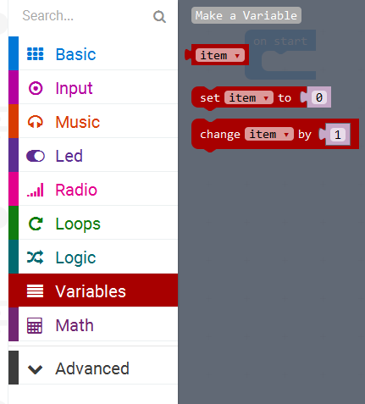

When prompted create new variables called: **playerCar**

At the start of the game we are going to place the car at the bottom middle of the display.

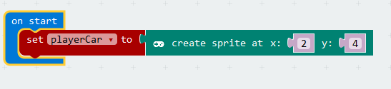

Now from the Game option set the score to 0.

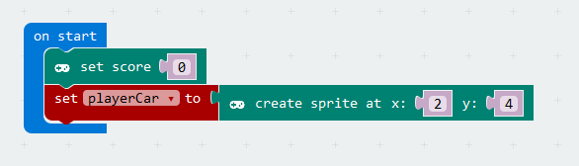

We are now going to add two event handlers to respond to the user interaction, when the user presses the button A or B. We will use code to move the car to the left or to the right by changing its X coordinate.

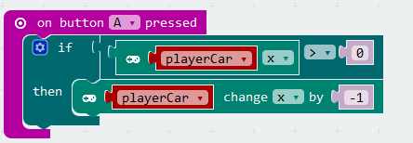

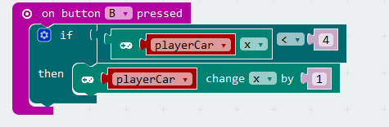

Let’s create a loop that runs indefinitely and it sets a variable called gameOn to true and pause for 100ms. At the end once the game will be over it will display a game over message with the final score.

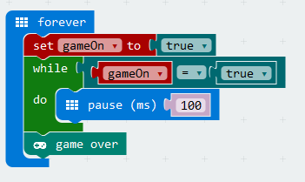

The first car called car0 will be positioned at the top of the screen on lane 0. It will then move downwards (by changing the Y coordinate of the car) till it reaches the bottom of the grid. Once at the bottom of the screen we can check if it is colliding with the player’s car. If not we reposition the car at the top of the screen and give it a randomised delay. Create a new variable called car0.

The purpose of the randomised delay is to make sure that all 5 cars do not all come down at the same time.

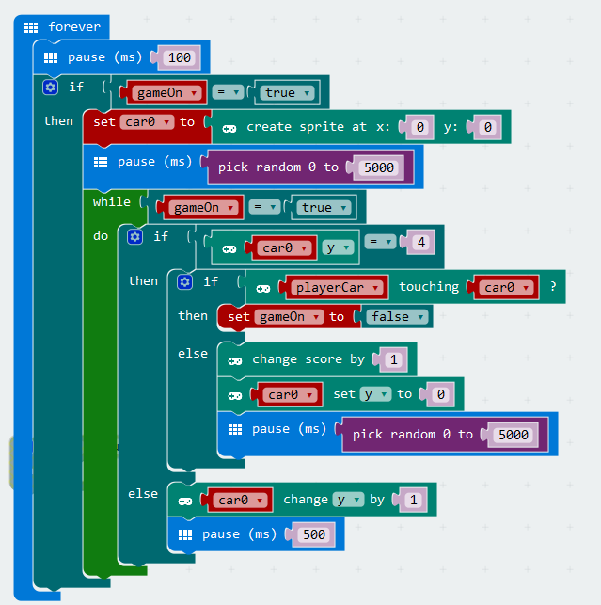

For this final step we can copy the code from step 3 and paste it for the other 4 cars (car1 to car4). Create new variables car1, car2, car3 and car4. Make sure you create sprite at x and y for each car correctly.

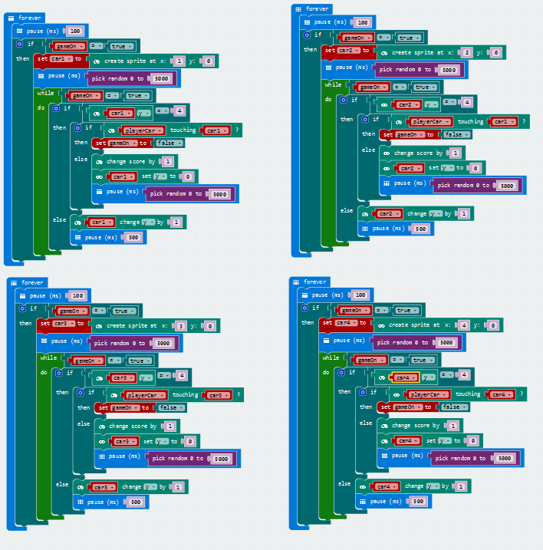

Update final game loop to print gameover.

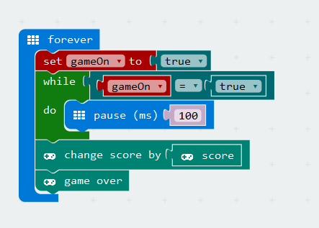

**Challenge:**

Tweak this code so that the game cars go faster and faster as the user’s score increases.